Every year Universiti Teknologi Malaysia (**UTM**) holds a knowledge sharing event through Center for Advancement in Digital and Flexible Learning (**UTM CDex**) which is called **NALI** (stands for New Academia Learning Innovation). It demonstrates multiple models of learning modes to achieve entrepreneurial academia, it was first introduced in 2018, and following its success it continued annually until 2023.

In the last Edition **NALI 2023** which was held between 6-8 November presenting the theme of Resilience Education for Future-Oriented Quality Graduate as it polishes the individual’s ability to bounce and blend into changes, avoid stress and diversity- based problems. It gives the suitable learnings and methods to develop problem-solving and social skills in addition to many more traits.

**Poster:**

**The Development of E-Bike Tracking System**

**for Bike Sharing in Promoting Transport Resilience**

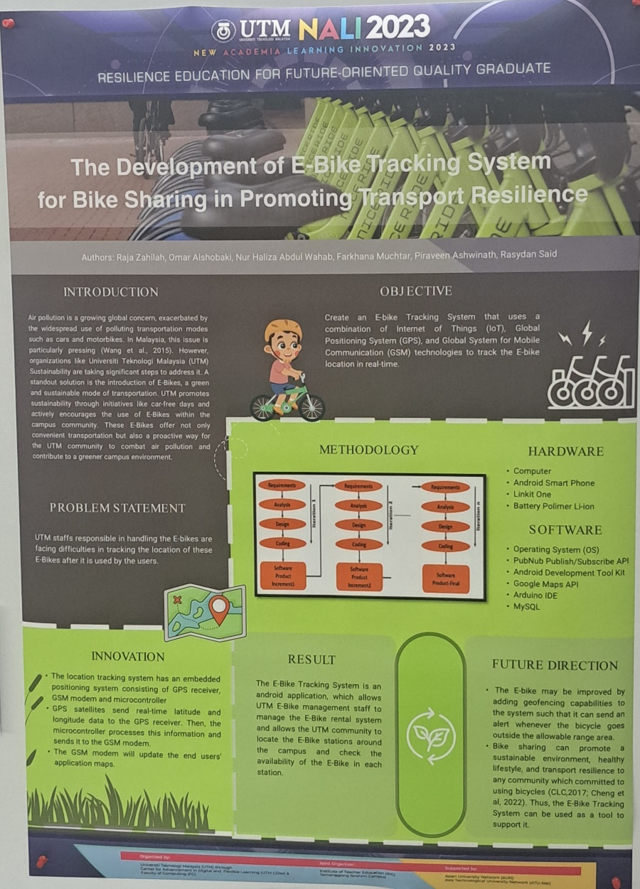

**Personal reflection:**

The poster on the E-Bike Tracking System shows a good idea by UTM Sustainability to help the environment with smart technology. The poster starts by explaining the problem of dirty air in Malaysia and how UTM is trying to fix it by using E-Bikes as a clean way of moving around the campus. The poster makes it clear why they need a system to track the E-Bikes and how they plan to do it.

They use a mix of IoT, GPS, and GSM technologies to create a real-time tracking system that works with an Android app. They list the different tools and platforms they use to build the system, such as Android Development Tool Kit, Google Maps API, and Arduino IDE. They also explain how they put GPS and GSM modules in the E-Bikes to send data to the app, making it easy for UTM staff to manage the bikes.

They also think about the future of their project and how they can make it better. They suggest adding geofencing features to stop people from misusing the bikes and expanding the system to other bike-sharing programs. They support their ideas with research that shows how bike-sharing can help the environment and the community.

Their poster shows that they care about sustainability, innovation, and well-being. They have created a complete solution that deals with both environmental issues and campus transportation needs.

**Conclusion**

1. Do the activities give benefit to the student?

2. How do these activities impact on the outcome of the course/subject?

3. Do you learn something impactful from the activity?

4. Do the activities spark excitement/interest in the student?

5. Do you feel that the visiting NALI 2023 and the interview sessions help you learn the course material better? Provide justifications.  
  
 I do think those activities in NALI2023 are directly useful for the learners as the applied methods to deliver the intended outcomes through the problem-solving based learning and other methodologies used. These activities are quite impactful, with engaging in NALI 2023 gives a broad perspective beyond the course/subject way that the students are used to, therefor it gives a more-comprehensive understanding of certain technologies in a way that they didn’t face.  
 As it’s obvious, the impact from the activity was wide ranged, from the practice of skills needed in various fields, from concluding remarkable points in a topic for interviewing to interviewing itself to reporting the scientific material behind the certain project, as all of this activities would spark a notable will to explore more with the same techniques and skills that are part of NALI2023, with visiting it gave me personally an unforgettable learning experience for the course in addition to the session done and listing to different participants explain their projects and even interviewing some of them. It was an overall unique and useful experience.